W06 Assignment: Explain Polymorphism
- Explain the meaning of Polymorphism.
Polymorphism means that the same method can behave differently depending on the object being used. In my program, I used polymorphism with the Goal class and the EternalGoal class. EternalGoal inherits from Goal, but it changes how some of the methods work by overriding them.
- Highlight a benefit of Polymorphism.
One benefit of polymorphism is that it makes the program easier to change and expand. I can create different types of goals that behave differently without having to completely rewrite the rest of the program. This makes the code more flexible.
- Provide an application of Polymorphism.
In my program, polymorphism is applied to the different types of goals. For example, my EternalGoal class overrides methods from the Goal class:
- Use a code example of Polymorphism from the program you wrote. (You should copy and paste a few lines of code that demonstrate the use of the principle.
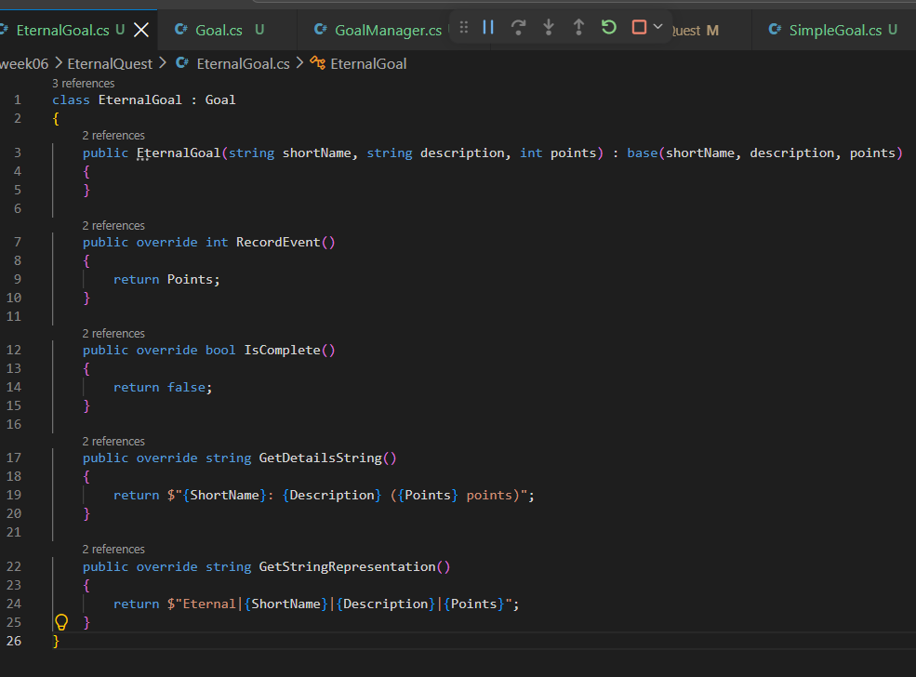
- Thoroughly explain these concepts. (This likely cannot be done in less than 100 words.)
These methods have the same names as the methods in the parent Goal class, but EternalGoal gives them its own behavior. For example, IsComplete() always returns false because an eternal goal does not get completed. This shows polymorphism because the program can work with a Goal while the specific type of goal determines what the methods actually do. This follows the idea from the teaching that different derived classes can have different behavior while still being used as the base class.
- Include the screenshot you took at the beginning of your team meeting.


